Title of M Sc Thesis (24)
(Binding Page)



Author (16)

Name of Student (16)
Student’s Registration Number (16)

Supervisor (16)

Name of Supervisor (16)
Supervisor’s Designation (16)

DEPARTMENT OF CIVIL ENGINEERING (15)
FACULTY OF CIVIL & ENVIRONMENTAL ENGINEERING (15)
UNIVERSITY OF ENGINEERING AND TECHNOLOGY
TAXILA (16)
Month Year
Thesis Title (18)
(Inside First page)

Author (12)
Name of Student (14)
Student’s Registration Number (14)

A thesis submitted in partial fulfillment of the requirement for the degree of (12)
M.Sc. Transportation Engineering (14)

Thesis Supervisor: 12
Supervisor’s Name 14
Designation & Department 14

11 External Examiner’s Signature:

11 Thesis Supervisor’s Signature:

15 DEPARTMENT OF CIVIL ENGINEERING
FACULTY OF CIVIL & ENVIRONMENTAL ENGINEERING
UNIVERSITY OF ENGINEERING AND TECHNOLOGY TAXILA

10 Month Year
ABSTRACT 14
Write abstract from here. The font of the entire document is Times New Roman size 12, regular, justified except headings. The length of the abstract should not exceed 1 page at maximum.

Keywords:

UNdertaking 14
Use the following undertaking as it is. 12
I certify that research work titled “enter title of your research proposal here” is my own work. The work has not been presented elsewhere for assessment. Where material has been used from other sources it has been properly acknowledged / referred.

Signature of Student

Name of Student

Registration Number

Acknowledgements 14
Write acknowledgment here. Use Times New Roman 12, justified.

Table of Contents 14
Sample is given below: 12
Abstract ………...ii
Acknowledgement iii
List of Figures vi
List of Tables vii
Abbreviations viii
Chapter 1: Introduction 1
1.1: Statement of the Problem 1
1.2: Objectives 3
1.3: Organization of the Thesis 3
Chapter 2: Overview of xyz scheme……………………………….……...4

Tab Space

List of figures 14
Sample is given below: 12

Number Page

Fig 2.1 Block diagram of xyz block 8
Fig 2.2 Basis Functions Diagram 9
Fig 2.3 Block Diagram of Codec 10
Fig 3.1 Encoder 13
Fig 3.2 Decoder. 14

Tab Space

List of tables 14
Similar to the list of figures. 12

Chapter 1 18
Name of Chapter 18 bold

  - Heading 1 14
All main headings in Times New Roman font size 14, bold. All the text in Times New Roman font size12, regular, justified & in 1.5 line spacing format. (One line space before next heading)

    - Subheading 1 12
All subheading1 in Times New Roman font size 12, bold.

      - Subheading 2
All subheadings in Times New Roman font size 12, bold.

  - Heading 2 14

Tab Space

Chapter 2 18
Name of Chapter 2 18 bold
2.1 Figure Style 14 bold
All figures should be centrally aligned with captions at bottom of figure.
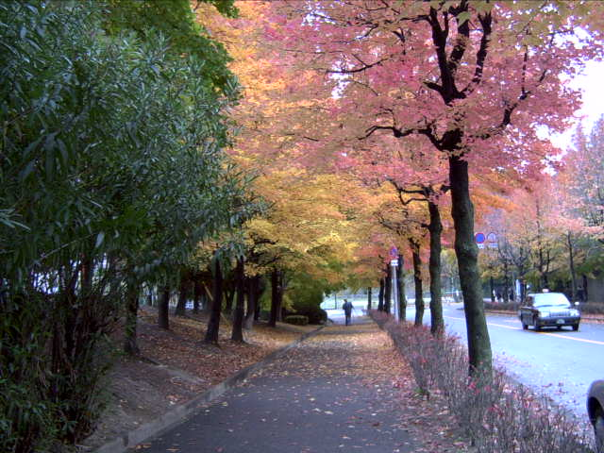
Fig 2.1: Autumn in Osaka, Japan 12

2.2 Table Style 14
All tables should be centrally aligned with captions at the top as sample given below:

Table 2.1: Table Caption 12
1
2

2.3 Equations Style
All equations should be centrally aligned with proper numbering. Use Microsoft Word Equation Editor. E.g.,
Note: Parameters used in equations should be written in italic in the text body e.g V,I,R. $V=\text{IR}$ (2.1)

CONCLUSIONS & RECOMMENDATIONS 14
Write conclusions and recommendations of your thesis here.

REFERENCES 12 bold
Citations in the text should be of the type: Stout, 1998; or Stockton and Gillete, 1990; or Zobeck et al., 1997; or Stout (1998) stated that…..; or Stockton and Gillete(1990) studied that..
Order references alphabetically. Order multiple listings by the same author(s) by date (with the earliest first).
Single author journal article: Author’s last name, initials. Year. Title of paper. Full name of journal, v. x, p. xx–xx.
Single author chapter or paper in a book: Author’s last name, initials. Year. Chapter title in Editor’s or compiler’s initials and last name, book title. City of publication, publisher, p. xx–xx.
Single author book: Authors last name, initials. Year. Book title. Publisher, city of publication, xxx p.
Multiple authors: First author’s last name, initials, the initials and last name of second author, initials and last name of third author (etc.), year, title, etc.
Computer programs on disk: Organization name. Year. Program name, version number. name of distributor, city of distributor.
Internet: Author name(s). Year of publication or last revision (if known). Title of document, title, or complete work (if applicable). <URL> date of access.
Reference Examples:
Stockton, P. and D.A. Gillette. 1990. Field measurements of the sheltering effect of vegetation on erodible land surfaces. Land Degradation & Rehabilitation v. 2, p. 77-85.
Stout, J. E. 1998. Effect of averaging time on the apparent threshold for aeolian transport. Journal of Arid Environments v. 39, n. 3, p. 395-401.
Webb, W. P. 1931. The Great Plains. University of Nebraska Press, Lincoln, 525 p.
Zobeck, T. M., T. E. Gill, J. E. Stout, M. L. Zhang, A. C. Kennedy, and J. M. Gregory. 1997. Analysis of laboratory-generated dust suspensions derived from soils and roads. Presented at the 1997 ASAE Annual International Meeting, Paper No. 972030. ASAE, 2950 Niles Road, St. Joseph, MI 49085-9659 USA.

Abbreviations 14
Abbreviations should be placed at the end. Sample is given below:
MTTP: M Sc Thesis Topic Proposal 12
BoPGS: Board of Postgraduate Studies
EED: Electrical Engineering Department

Annexure 14
Annexure (if any) should be placed at the end of thesis report. 12
Hard Copy Information:
Page Size: Letter (8.5” x 11”)
Page Margins: Top & Bottom = 1” and Left = 1.5” & Right = 1.25”
Page orientation: Portrait
Line Spacing: 1.5
Page Numbering: Bottom Center
Printing: One Side
Note about Binding:
Six hard bound copies of the thesis are required to be submitted for final thesis examination. Hard bound means permanently stitched and bound in BLACK COVER with the title of the dissertation and your name clearly inscribed on the cover as per format given at the first page of template in GOLDEN color. The SPINE of thesis should have Author’s Name (all capital letters), MSc. Engg. and Year of Passing ONLY. The Author’s name should be in vertical orientation while MSc. Engg. and year of passing. should be in horizontal orientation on hard bound copy of thesis.

